CVS Report

Requirements Definition

Version 1.0

Doc. No.:

Revision History

Date | Version | Description | Author
2004-11-24 | 0.01 | Initial Draft | DV

Table of Contents
1. Introduction 4
1.1 Purpose of this document 4
1.2 Intended Audience 4
1.3 Scope 4
1.4 Definitions and acronyms 4
1.4.1 Definitions 4
1.4.2 Acronyms and abbreviations 4
1.5 References 4
2. Requirements Description 4
2.1 Introduction 4
2.2 General requirements 5
2.3 Specific requirements 1 5
3. Use Case Models 5
3.1 Webpage Generate Report 5
3.1.1 Register new user 6
3.1.2 Management of website through Admin account 6
3.1.3 Generation of template and generation of pdf report in eclipse. 7
3.2 Use case model 2 7
4. Requirements Definition 7
4.1 Requirement Group Definitions 7
4.2 Requirement Sources 7
4.3 Requirements definitions 8
4.3.1 Change Log 9
5. Future Development 9
5.1 General Overview 9
5.2 Specific group 1 9

Introduction

Purpose of this document
To give the ST and customer a document which will establish what the project shall produce anything not mentioned in this document is referred as shall not result from the project.

Intended Audience
This document is intended for ST, customer and core development team.

Scope
In this document there will only be use case models and a set of textual requirements.

Definitions and acronyms

Definitions

Keyword | Definitions

Acronyms and abbreviations

Acronym or  abbreviation | Definitions
ST | SteeringGroup

References

Requirements Description

Introduction
This project will produce a product which will be able to present a graphical user interface to the CVSQL application through eclipse as a plugin and in a webpage where you can generate pdf and html files.

General requirements
With this application it shall be possible to easily view and generate templates that later on can be used to generate pdf or html page.

Specific requirements 1
CVSQL project is a dependency since all quires to the cvs log will be directed to the project

Use Case Models

Webpage Generate Report
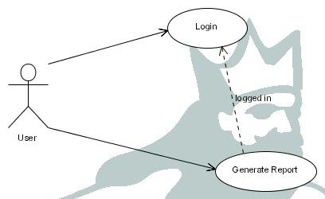

Initiator:
User

Goal:
To generate a report from a report template

Main Scenario:
1. User logs into the webpage
2. user chooses to generate his default report template in pdf format
3. a pdf file is presented in a new window
Extensions:
If a user chooses to generate the non default report template then the system will
ask the necessary question to be able to construct a sql query.
…

Register new user
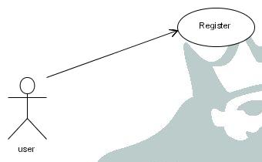

Initiator:
User
Goal:
To register an account on the webpage
Main scenario:
- The user fills out a form with personal information such as first and last name and e-mail
- the system validates all the fields if they are correct an account is created

Extensions:
- If the user tries to register an account with a username that is already present in the system will prompt an error message and clear all fields.
- if the user does not fill out all fields the system will require the user to do so.

Management of website through Admin account
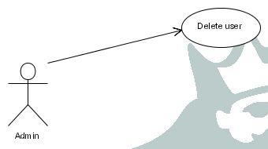
Initiator:
Admin
Goal:
To delete a user from the webpage system
Main scenario:
- The admin logs into the system and in the admin page chooses a user from a dropdown box and clicks on a delete button
- the system removes the user from the database, but his report templates are not removed
Extensions:
- If the user is currently logged into the system when admin performs this action the user will not be be logged out instantly instead when his session is finished he can not log in again simply.

Generation of template and generation of pdf report in eclipse.
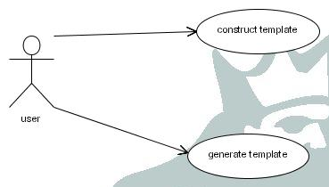
Initiator:
User
Goal:
To construct a report template and generate a pdf file
Main Scenario:
- The user creates a report template by using the graphical interface and stores the template
- The user chooses from the graphical interface to generate a pdf and generates the default report.
- the system generates a pdf file and launches it.
Extensions:
1. if the user does not want to generate a pdf from the default report he must choose another report from a drop down box.

Use case model 2

Requirements Definition

Requirement Group Definitions

Identification | Requirement Group | Rem.
WB | Webpage
EC | Eclipse Plugin

Requirement Sources

Source | Description | Rem.
CS | Customer
EC | Eclipse plugin
…

Requirements definitions

Identity | Sta  tus | Prio  rity | Description | Source
 |  |  | System Administration
WB-001 | I | 1 | Definition: It shall be possible to login into the webpage  Motivation: some security is needed therefore login is required to use the webpage application | CS
WB-001 | I | 1 | Definition: it shall be possible to register a new user  Motivation: To be able to login to the webpage you must first be able to register | CS
WB-002 | I | 1 | Definition: It shall be possible to generate pdf or html page from report template  Motivation: to be able to view cvs log information in a simple manner | CS
WB-003 | I | 1 | Definition: It shall be possible to choose one query from x query’s in the users report template  Motivation: The user will most likely want to choose another report to generate | CS
WB-004 | I | 1 | Definition: It shall be possible for the user to dynamically specify certain criteria’s for the sql query’s  Motivation: the user might not want to choose the current week, month or day, but instead he wants to choose some other date. | CS
WB-005 | I | 1 | Definition: It shall be possible for a admin to manage the website, i.e. delete users.  Motivation: to enhance security so that idle users can be deleted and extra functionality can be added later | CS
 |  |  | Data Exchange
EC-001 | I | 1 | Definition: It shall be possible to construct sql query’s by a simple user interface  Motivation: One can not assume that every user of this product knows the sql query language. | CS
EC-002 | I | 1 | Definition: It shall be possible to store report templates in the form of xml files.  Motivation: to make the project useable you should not have to define the report templates every time you run the application. | CS
EC-003 | I | 1 | Definition: It shall be possible to generate a pdf and html page from a report template  Motivation: to be able to view cvs log information in a simple manner | CS

Requirement status:
I = initial (this requirement has been identified at the beginning of the project),
D = dropped (this requirement has been deleted from the requirement definitions),
H = on hold (decision to be implemented or dropped will be made later),
A = additional (this requirement was introduced during the project course).

Change Log

Identity | Action | Date | Comments
DV | A | 2004-11-25 | Revised and added some text

Requirement status:
D = dropped (this requirement has been deleted from the requirement definitions),
H = on hold (decision to be implemented or dropped will be made later),
A = added (this requirement was introduced during the project course).
R = resurrected (dropped or on hold requirement was reactivated)

Future Development
WebPage
- A more elaborate security for handling login and storage of information, such as ssl login and encrypted passwords.
- Graphical Preview of reports before they are generated so that the user can see if the report he has designed is really what he wants instead of waiting for the application to generate the pdf or html and then redo the whole phase again.
- Graphical preview of certain basic styles from which the user can pick one to add to his report.
- Configuring a standalone client that can auto generate certain reports at certain date and time and send via e-mail to user or by some other communication means. If you are project manager you might want to have a report done once every week, by using this standalone client you do not have to do the work your self.

Eclipse Plugin
- Storing predefined sql query under definitions, which the use can choose from as a option for the user they should be fairly rudimentary.

General Overview
One of the basic ideas that is missing from this project is a preview component, which is a great tool for the users to have it greatly increases usability.

Specific group 1
More collaboration and communication in the beginning of the project phase it’s extremely easy to drift apart if the group does not hold meetings with each other at least two times per week.

